CSA1606-DWDM
KNIME Application Development Activities
(Do any two)

Activity 1: Sales Analysis Dashboard
Problem Statement
A retail company wants to analyze its monthly sales.
Task
Build a KNIME workflow that:
- Imports a sales dataset.
- Cleans missing values.
- Calculates monthly sales.
- Identifies the top 10 products.
- Creates bar and line charts.
- Generates a summary report.
Expected Outcome:
An interactive sales analysis workflow.
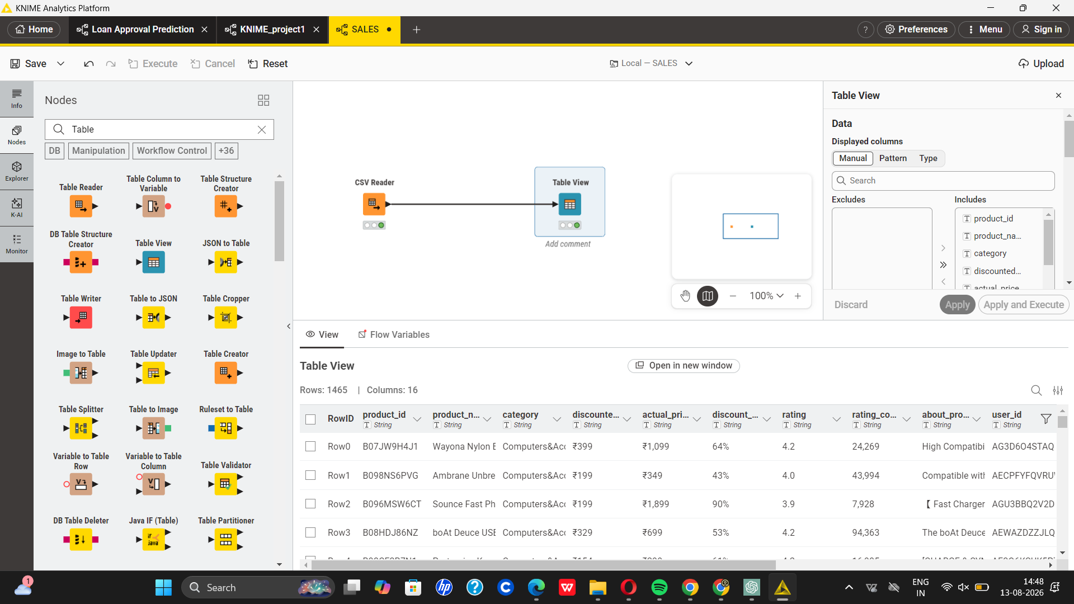
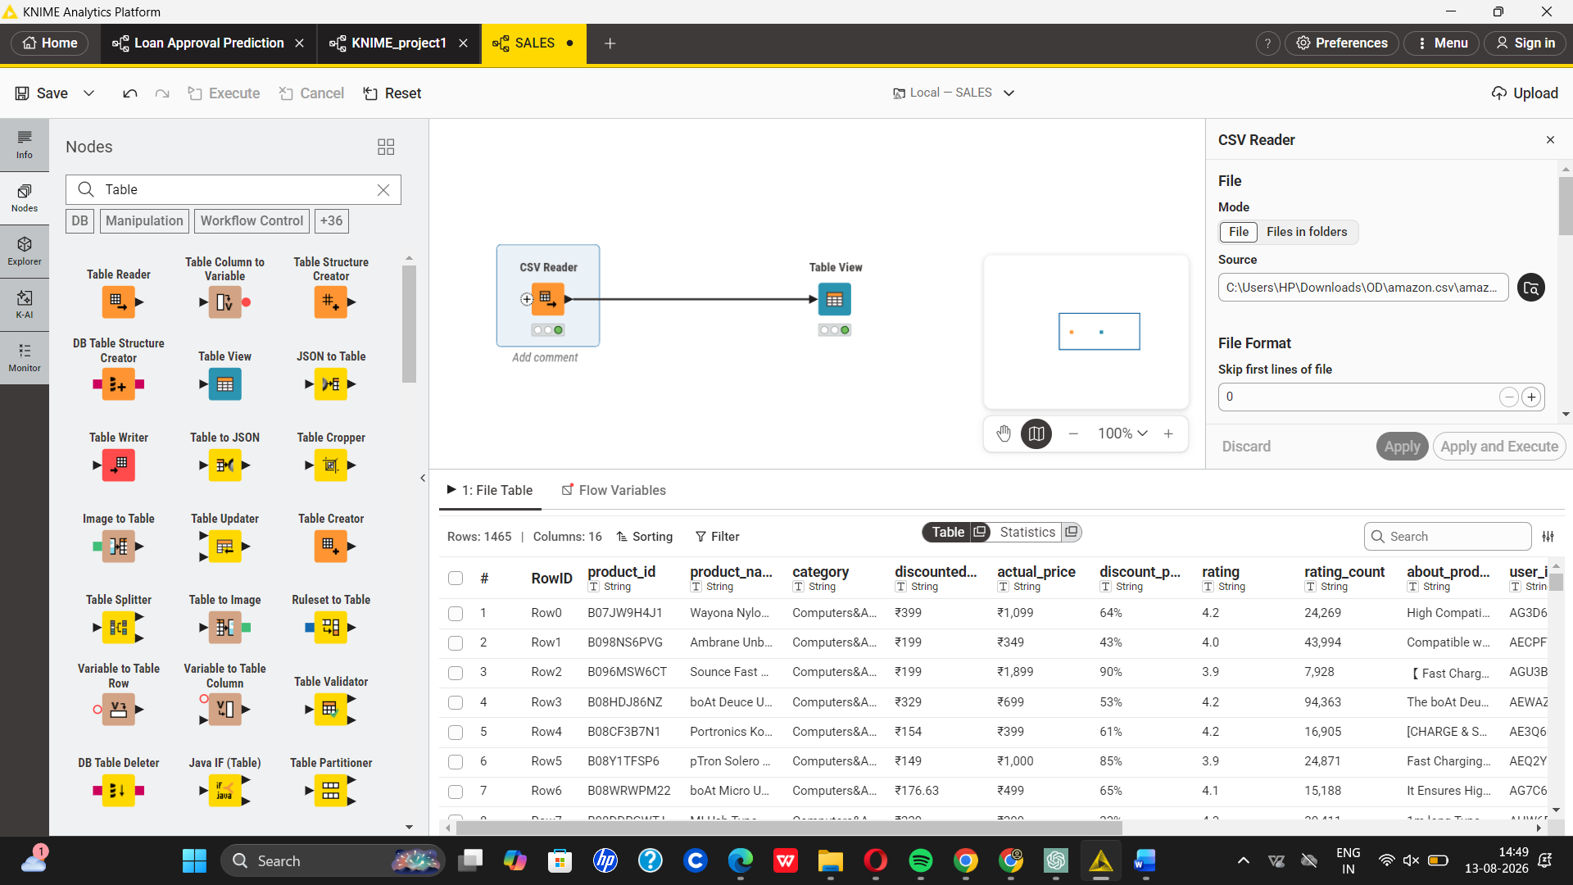
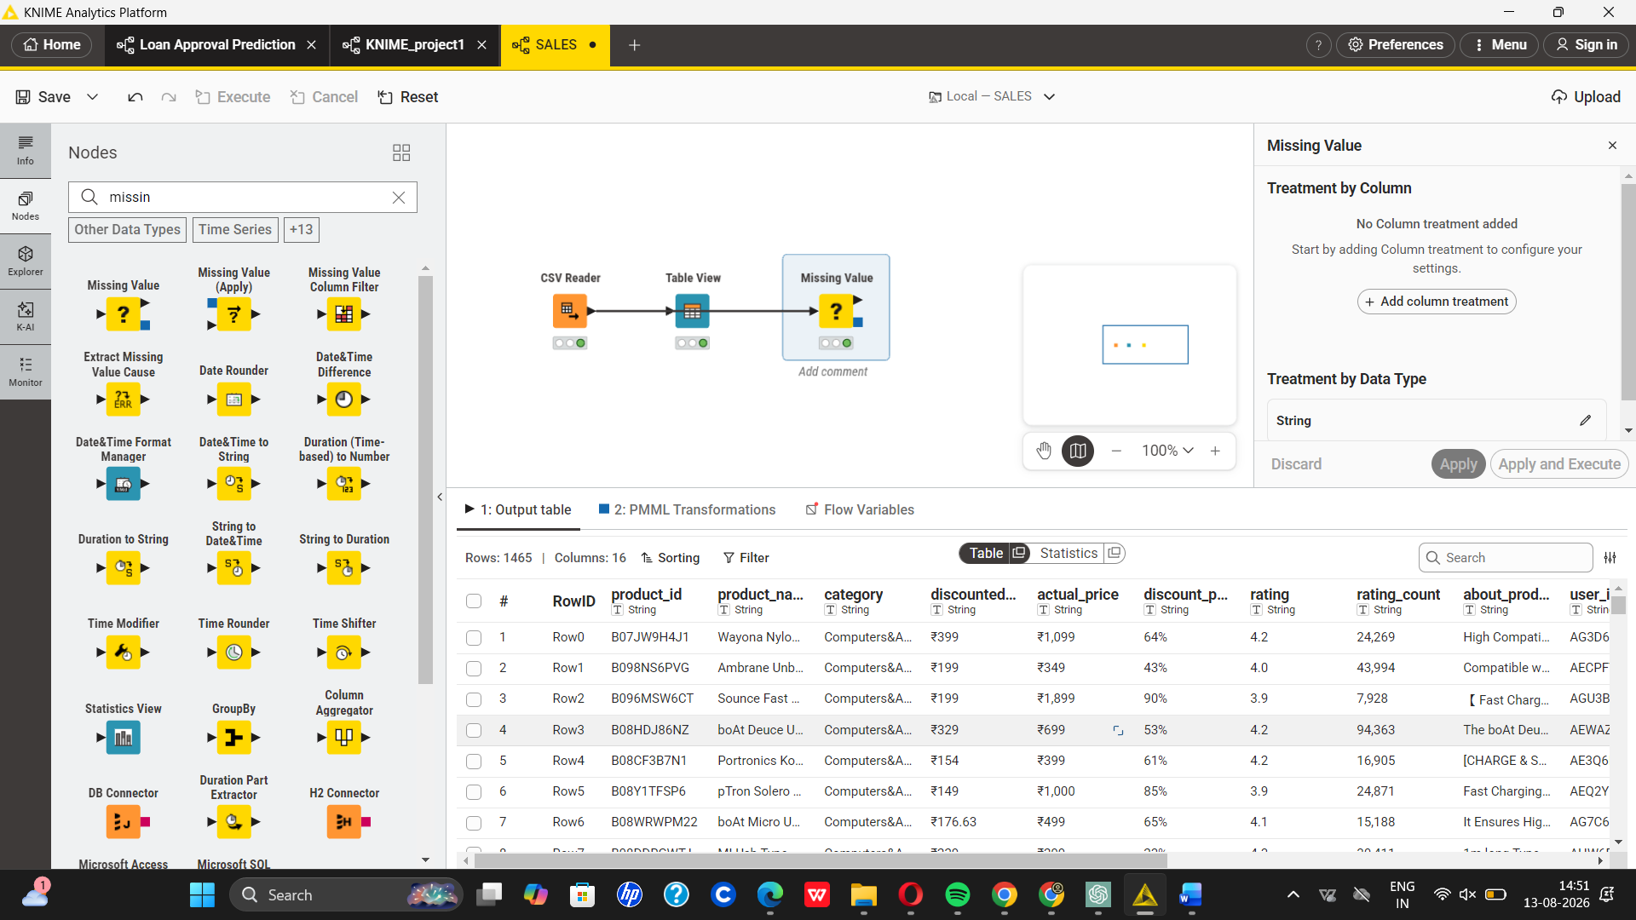

Activity 2: Hospital Patient Risk Prediction
Problem Statement
A hospital wants to predict whether a patient is at high or low health risk.
Task
Develop a workflow to:
- Import patient records.
- Preprocess data.
- Train a Decision Tree model.
- Predict patient risk.
- Evaluate accuracy using a confusion matrix.
